Permutation:
A permutation is an arrangement of objects in a definite order. The members or elements of sets are arranged here in a sequence or linear order.

Example 01:
The permutation of set A={1,6} is 2, such as {1,6}, {6,1}. As you can see, there are no other ways to arrange the elements of set A.

Example 2:
The permutation of set B={1,4,5} is 6, such as
{1,4,5}{1,5,4}
{4,5,1}{4,1,5}
{5,1,4}{5,4,1} .
As you can see, there are no other ways to arrange the elements of set B.
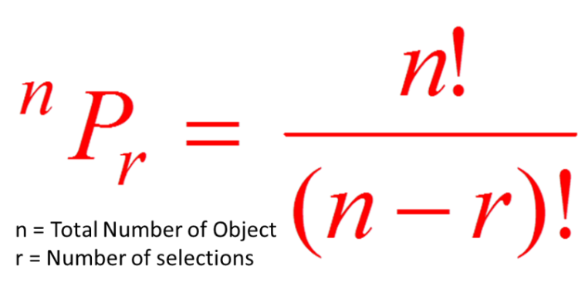

Combination:
A combination is a mathematical technique that determines the number of possible arrangements in a collection of items where the order of the selection does not matter with only unique combination where items are not repeating.

Example01:
The Combination of set A={1,6} is 1, such as {1,6}. As you can see, there are no other ways to arrange the elements of set A with a unique combination where items are not repeating..

Example 2:
The permutation of set B={1,4,5} is 3, such as {1,4,5}, {4,5,1}, {5,1,4}. As you can see, there are no other ways to arrange the elements of set B with unique combination where items are not repeating..

